**EXPLORING ENVIRONMENT LIGHTING SETTINGS**

This tutorial will help in understanding of how Exploring Environment Lighting Settings works and why it is needed.

Lighting in Unity is not governed solely by lights placed in the Scene, but also by Global Illumination.

Global Illumination is a series of algorithms that calculate direct and indirect light.

Steps to apply environment lighting :-

Step 1

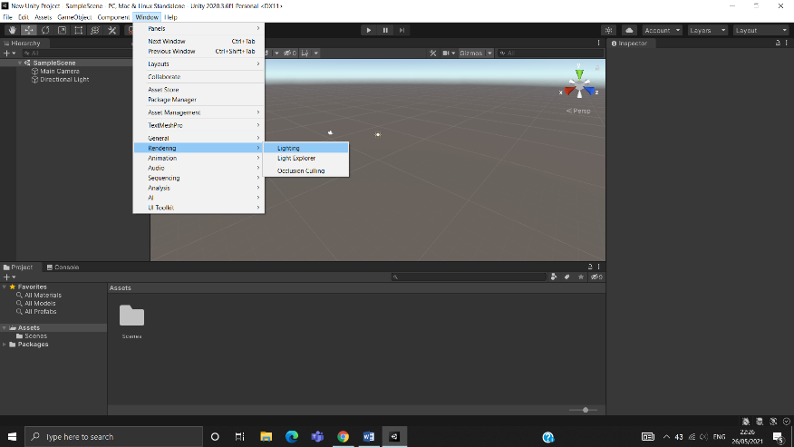For lighting setting of a environment, you can do this by selecting **Window > Rendering** > **Lighting Settings** from the toolbar.

Step 2

The first section of the lighting settings window manages the setting for scene to Default-Skybox, ambient lighting, and refelection.

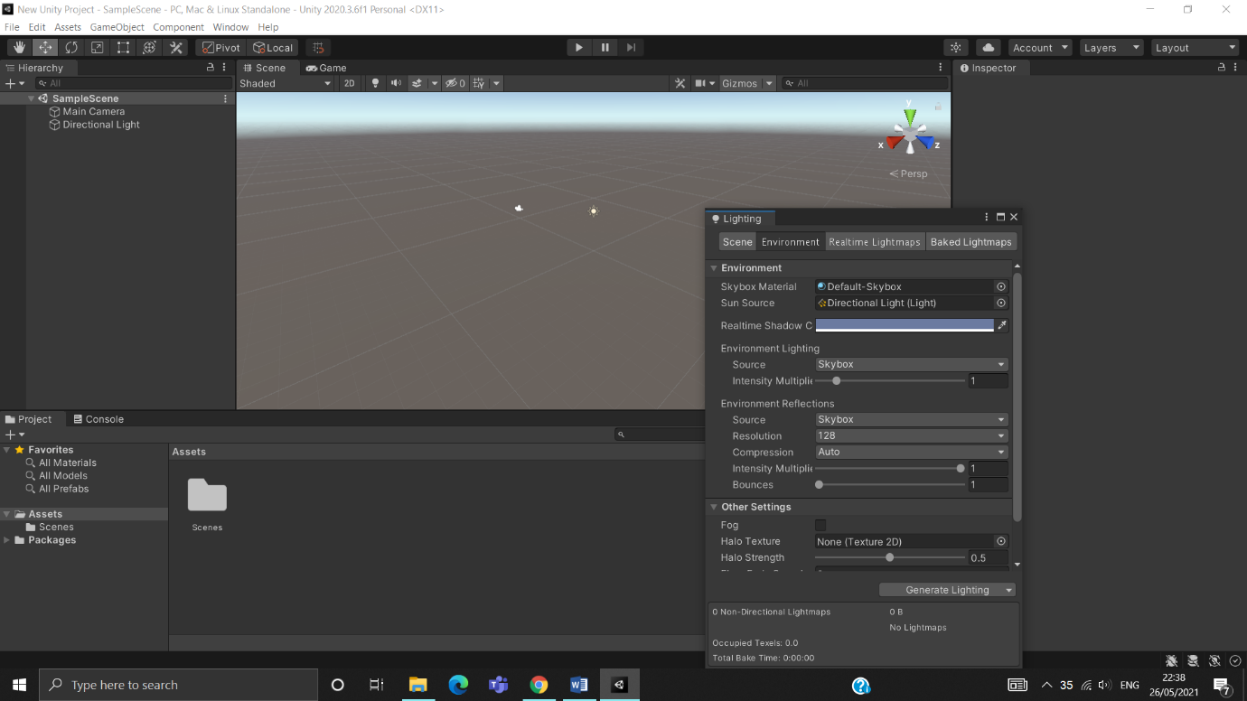

Step 3

Environment Lighting has two other color - options Gradient and Color.

The color-based options allow the user to a three color gradient, or a single color ambient light.

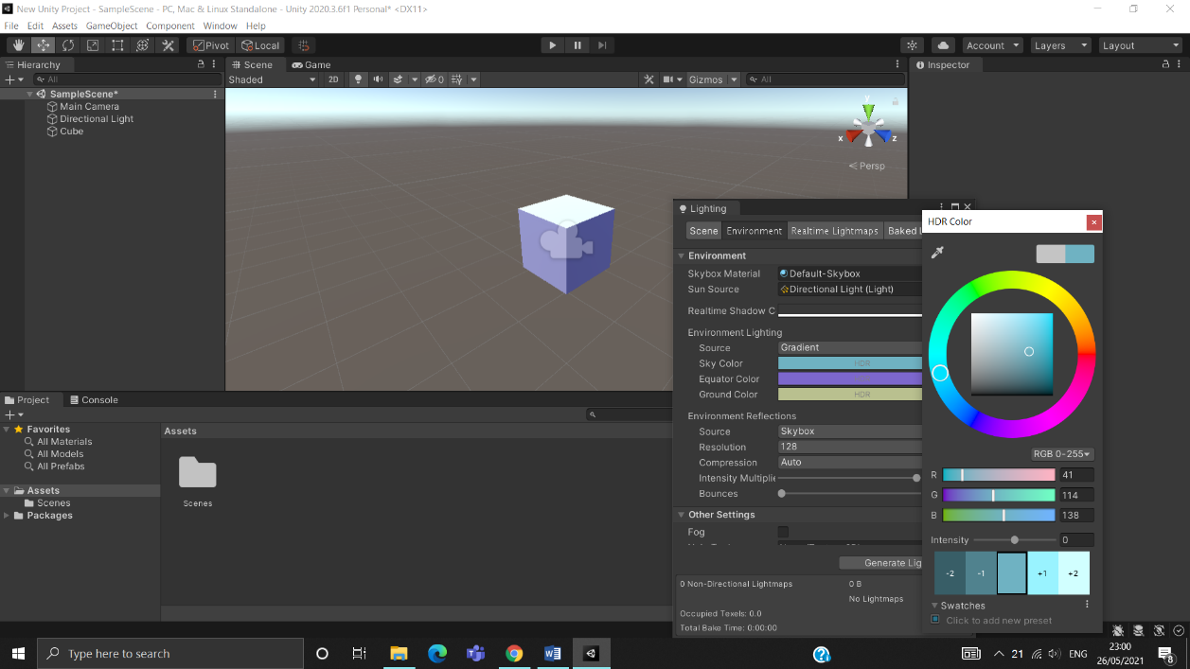

Step 4

Using the Skybox option, adjust the Intensity Multiplier. This can increase or decrease the ambient light. Default value is 1 and minimum value is 0.

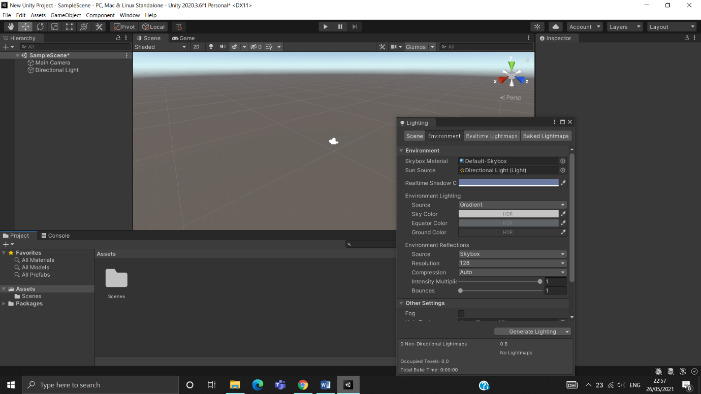

Step 5

The final option is shared by all three source type is gradient, skybox and color. 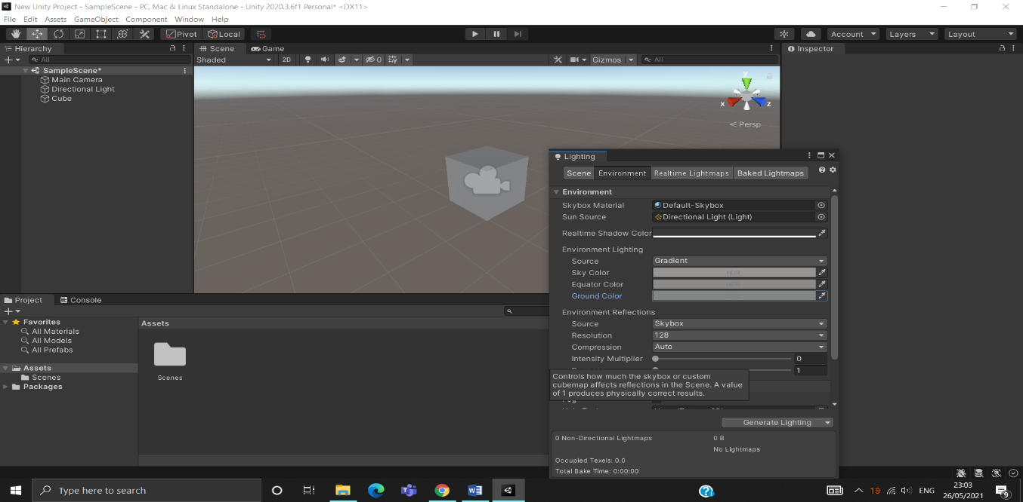

Conclusion:-

In this tutorial you have learned about how to use the light settings, global illustration, about directional light and procedural light boxes, ambient lighting, HDR. With the help of these you can use Global Illustration and create best lighting projects.